Name: | ___________________________________________ |  |  |  | Date:__________
 | Maths Specialist Unit 2 - Investigation 5 – 2015  Complex Numbers and Transformations  In-class investigation |  |  |  | / 42  -------- %
Important Information:
Although the take-home component is not worth any marks, it is essential in preparation for the in-class component. Knowledge and skills gained will be extended in the in-class validation component. This in-class validation will be completed under test conditions on the day in which this take-home component is due. The take-home component may be used when completing the in-class component. Contact may be made to parent(s) if the take-home component is not available for submission (at the start of the lesson).
Date out: |  | Week ____ Date __________ | Date Due: | Week ____ Date _________
Take home component weighting: |  | 0% of the year | In-class component weighting: | 7% of the year.
AIM: In this assessment, you will be investigating Complex Numbers and Transformations

Complex Numbers and Transformations Name: ……………………………….

In this task students will consider a set of points, in the z-plane and their transformation onto a set of image points and, in the w-plane.

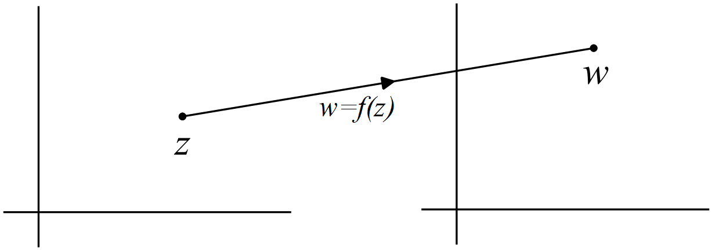
z-plane w-plane

The vertices of triangle ABC in the z-plane are given by:
.

Question 1 (9 marks)
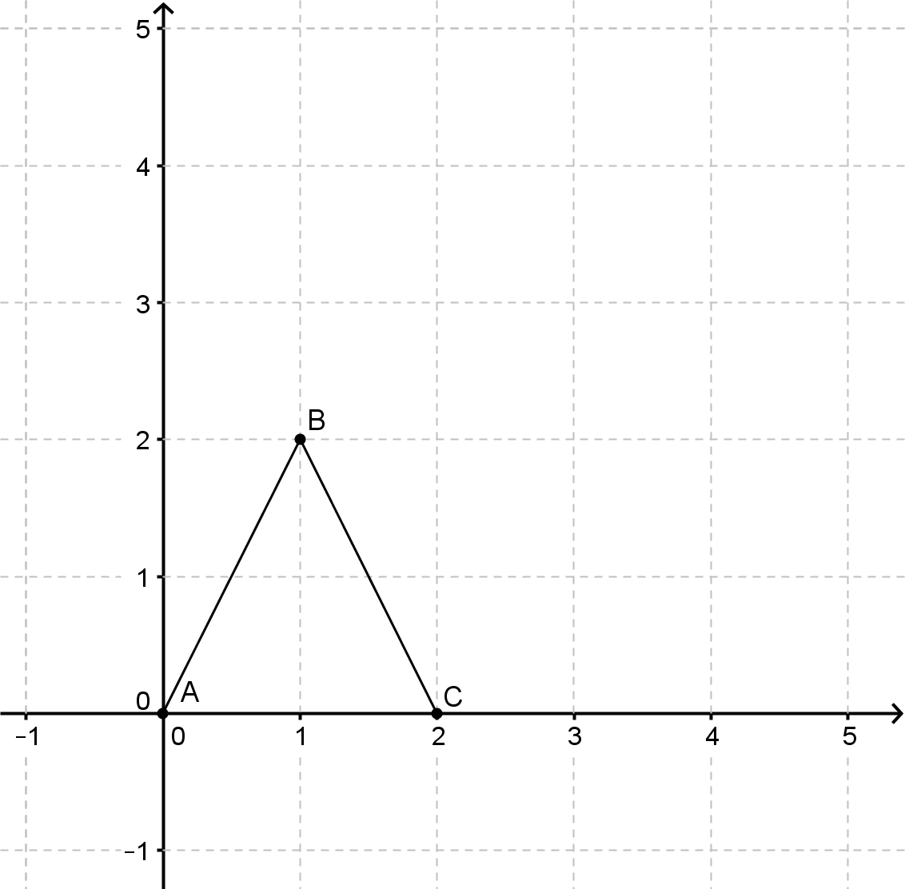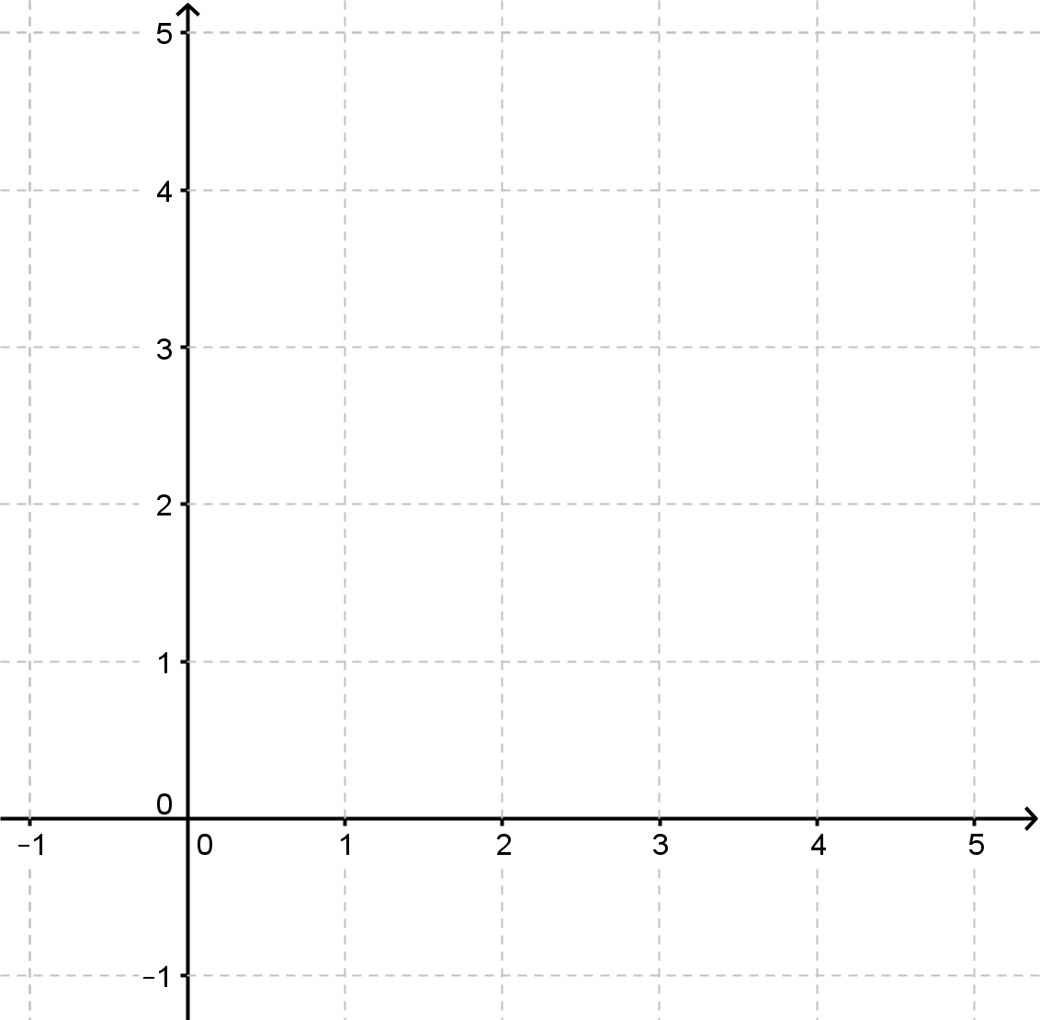
z-plane w-plane

(a) Using, determine the images and, of each of the three vertices, and plot them on the w-plane above. (2)

(b) Using, determine the images and, of each of the three vertices, and plot them on the w-plane above. (2)

(c) Use the axes below to investigate the transformation $f\left(\text{z}\right)\text{= z + }\left(\text{a + bi }\right)\text{, a, b ∈}$ℝ
.
(3)

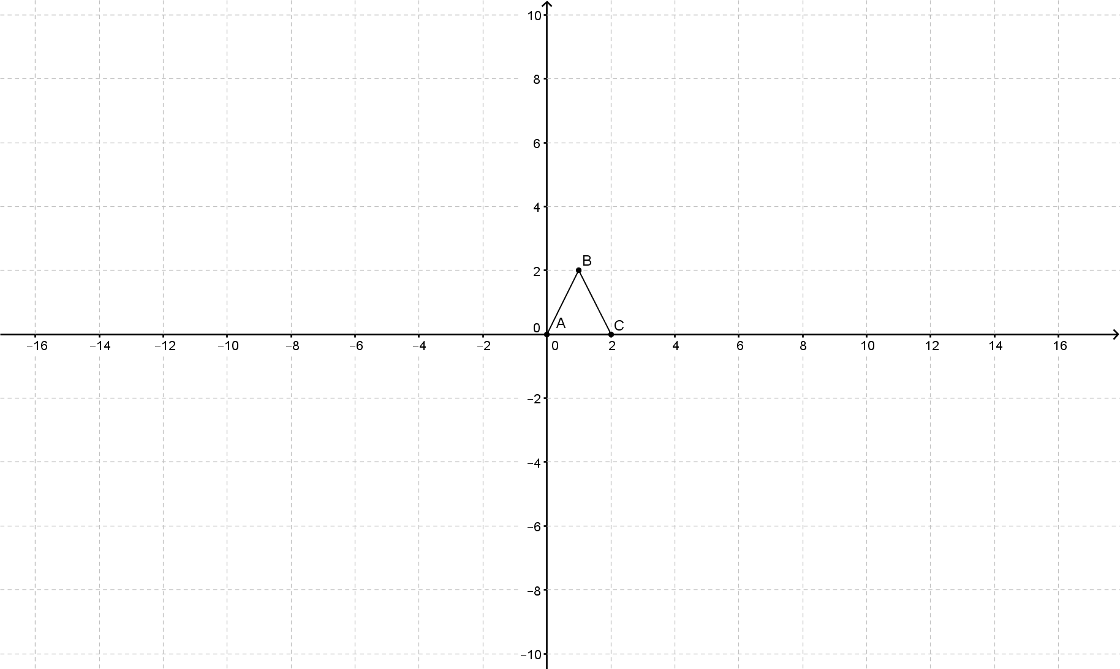

(d) Describe the transformation $f\left(\text{z}\right)\text{= z + }\left(\text{a + bi }\right)\text{, a, b ∈}$ℝ. (2)


z-plane
Question 2 (8 marks)
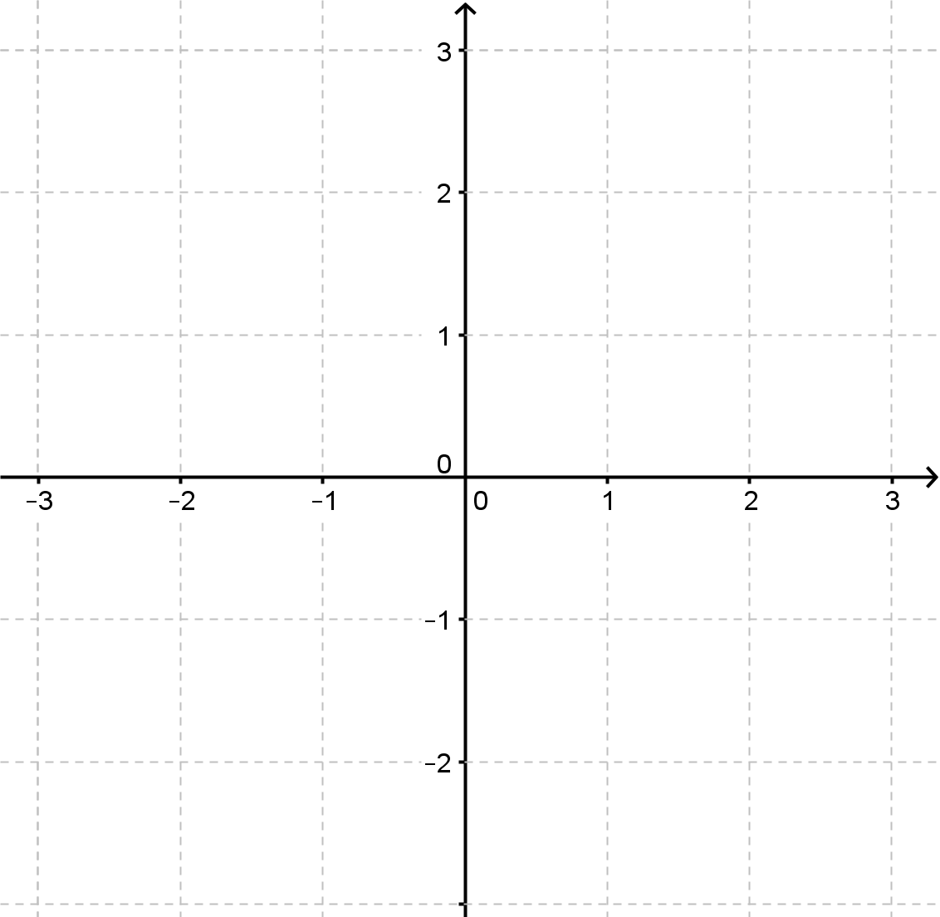
w-plane

(a) Using , determine the image of each of the three vertices, and , and plot them on the w-plane above. (2)

(b) Describe the transformation . (1)

(c) Definethat will result in triangle ABC being reflected in the vertical axis.
(1)

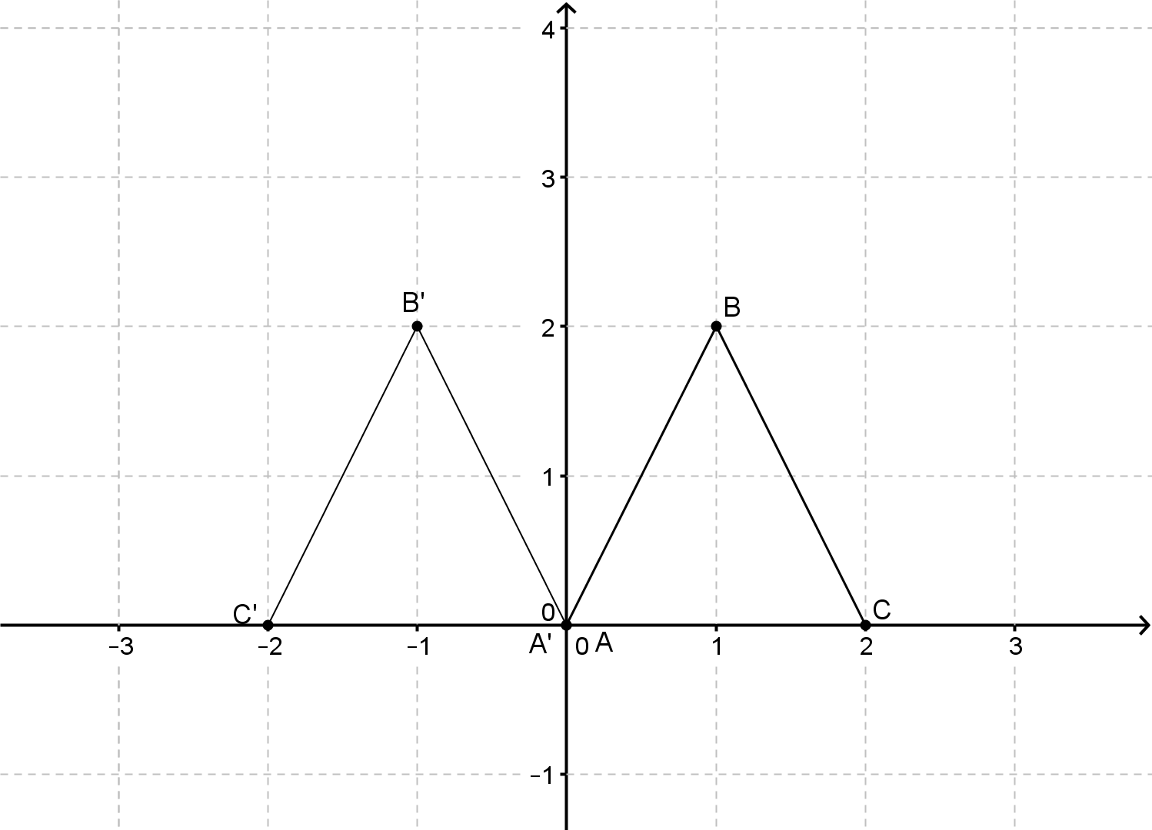

(d) Definethat will result in triangle ABC being reflected in the line . (2)

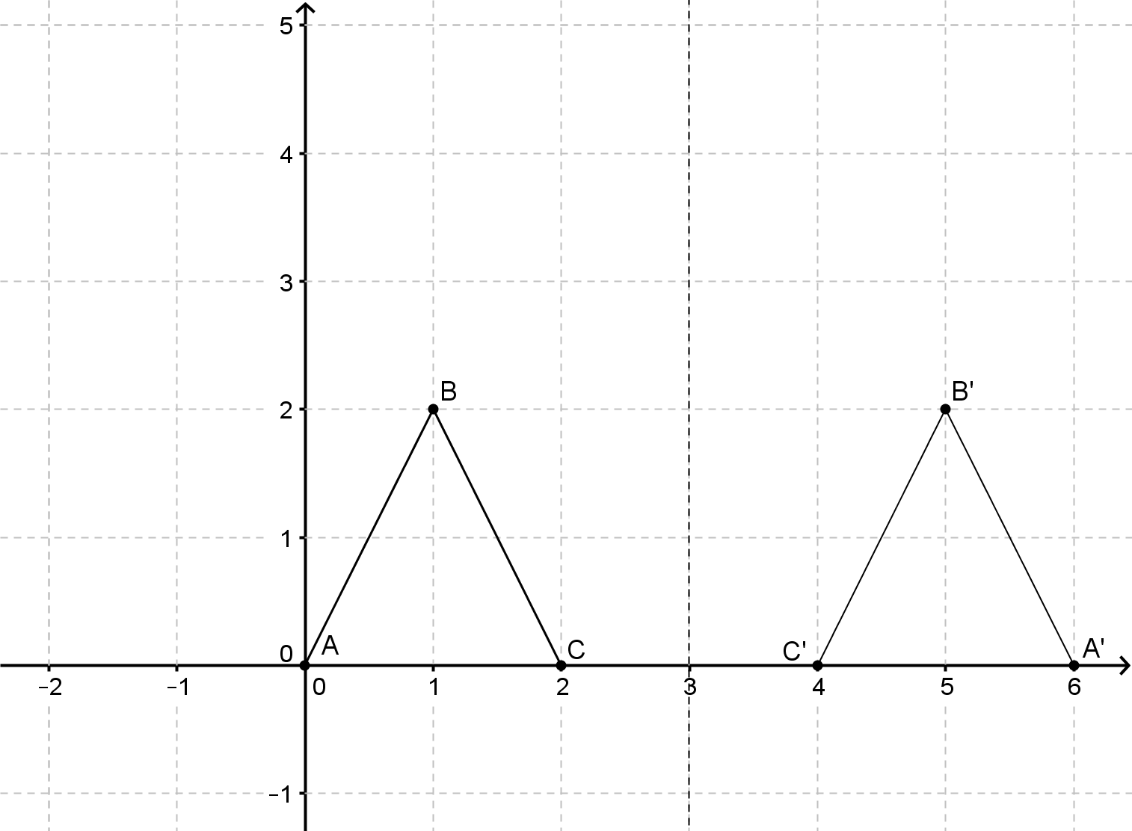

(e) Definethat will result in triangle ABC being reflected in the line . (2)

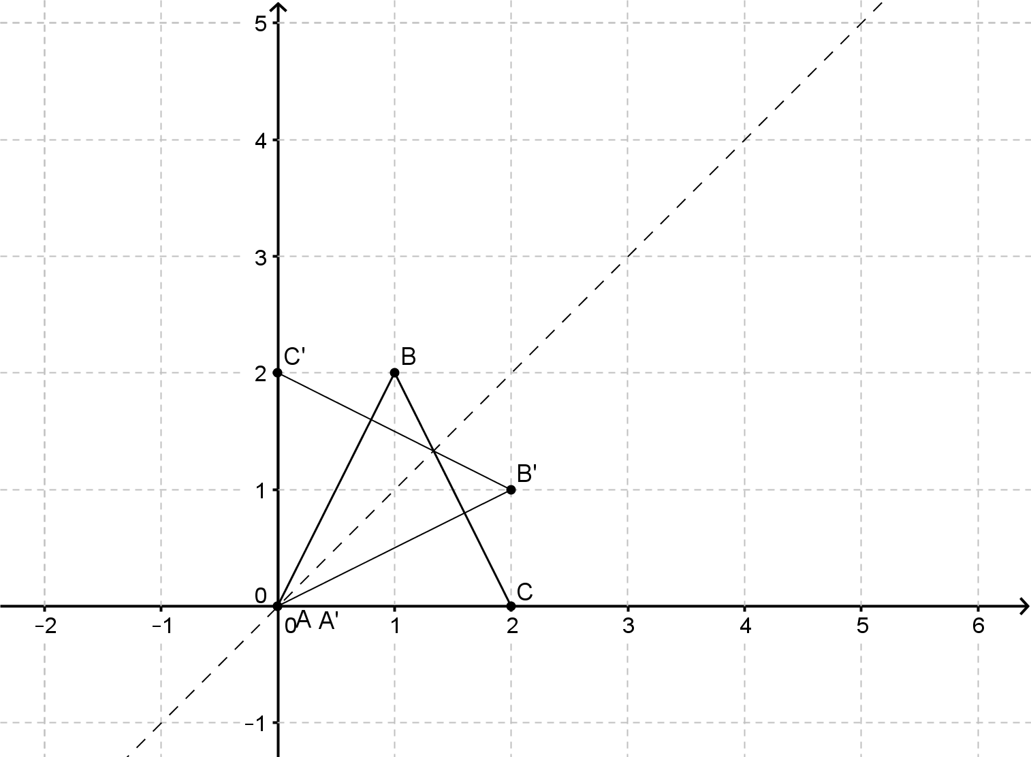


z-plane
Question 3 (3 marks)

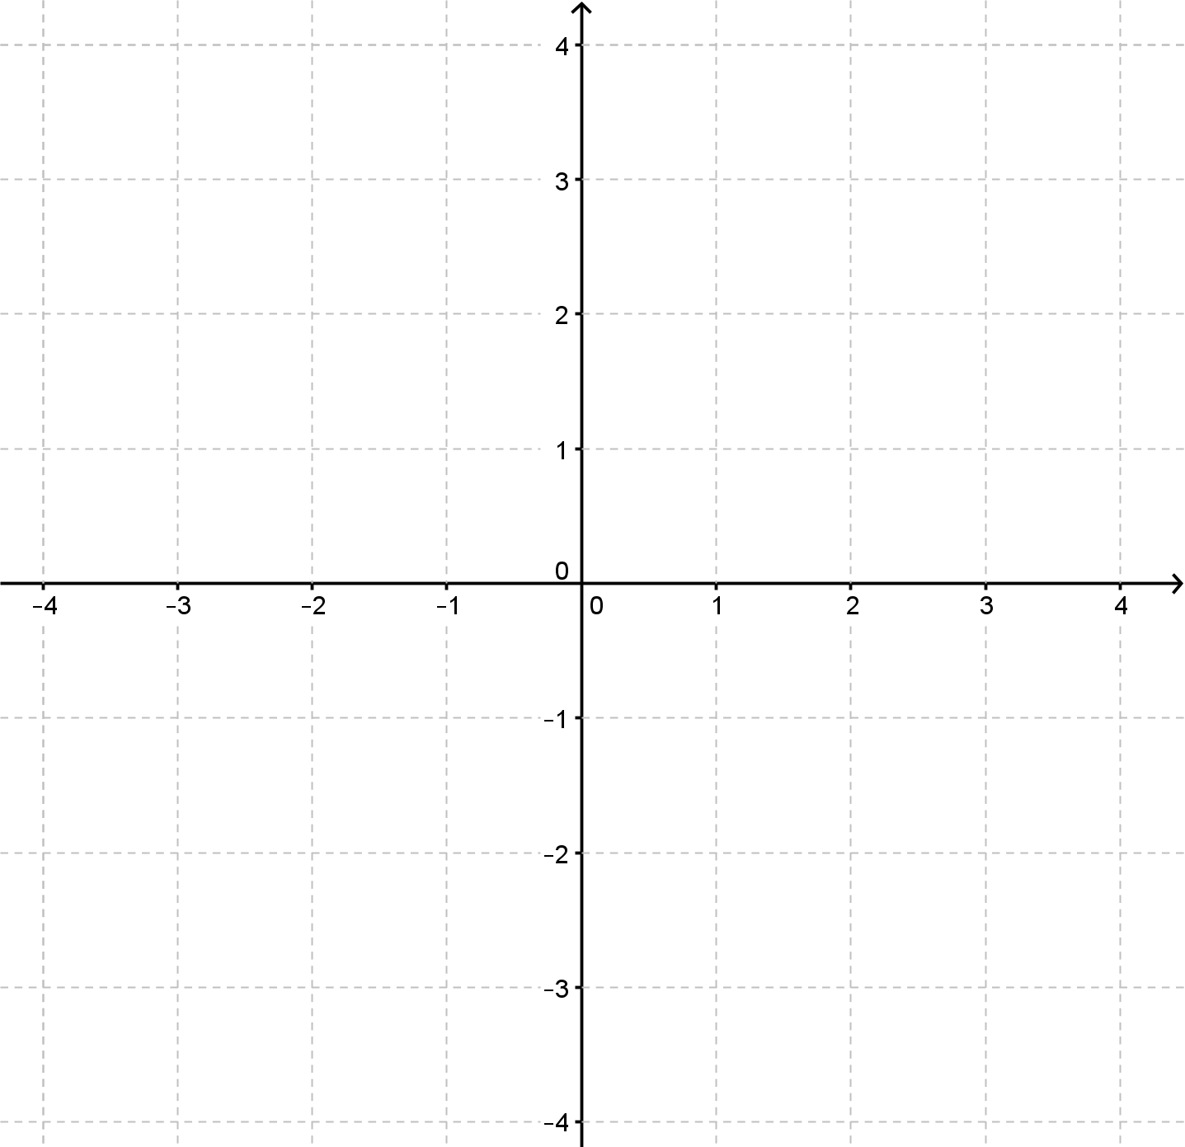
w-plane

(a) Using, determine the images and, of each of the three vertices, and plot them on the w-plane above. (2)

(b) Describe the transformation . (1)


z-plane
Question 4 (10 marks)

w-plane

(a) Using , determine the images and , of each of the three vertices, and plot them on the w-plane above. (2)

(b) Using , determine the images and , of each of the three vertices, and plot them on the w-plane above. (2)

(c) Describe the transformation $f\left(z\right)=kz, k ∈\text{R ,} k\text{ > 0}$. (1)

(d) Describe the transformation . (1)

(e) Investigate and hence describe the transformations.
(4)


z-plane
Question 5 (7 marks)

w-plane

(a) Using , determine the images, and , of each of the three vertices and plot them on the w-plane above. (2)

(b) Describe the transformation . (1)

(c) Describe the transformations . (4)

Question 6 (5 marks)
Identify the compound transformations represented by each of the following transformation functions.

(a) (3)

(b) (2)

Complex Numbers and Transformations

In-class investigation
Solutions and marking key

Question 1 (a)

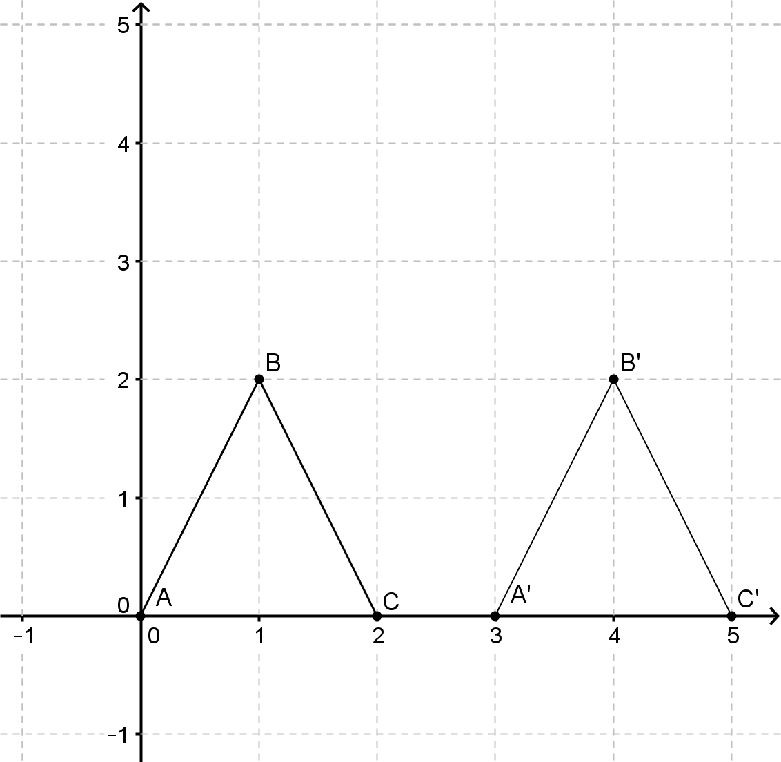

Marking key/mathematical behaviours | Marks
- Correctly determines the image of the three vertices  - Plots the three images | 1  1

Question 1 (b)

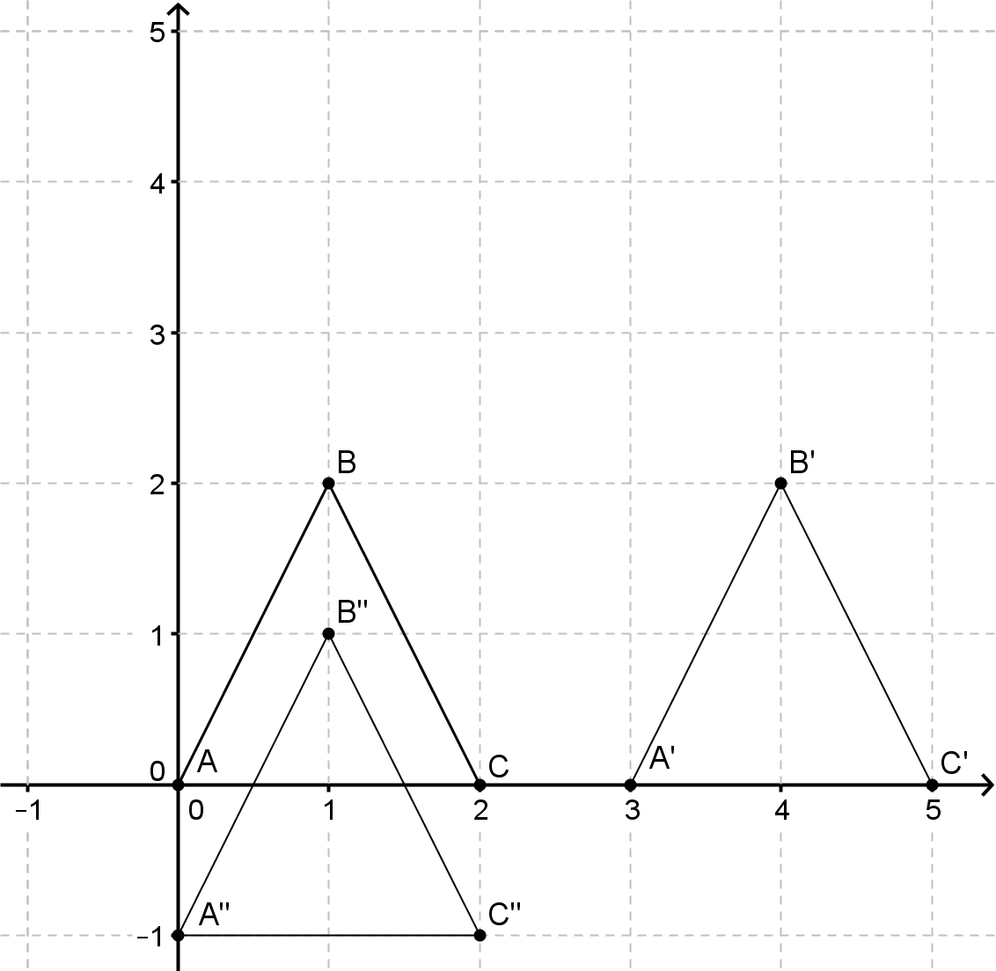

Marking key/mathematical behaviours | Marks
- Correctly determines the image of the three vertices  - Plots the three images | 1  1

Question 1 (c)

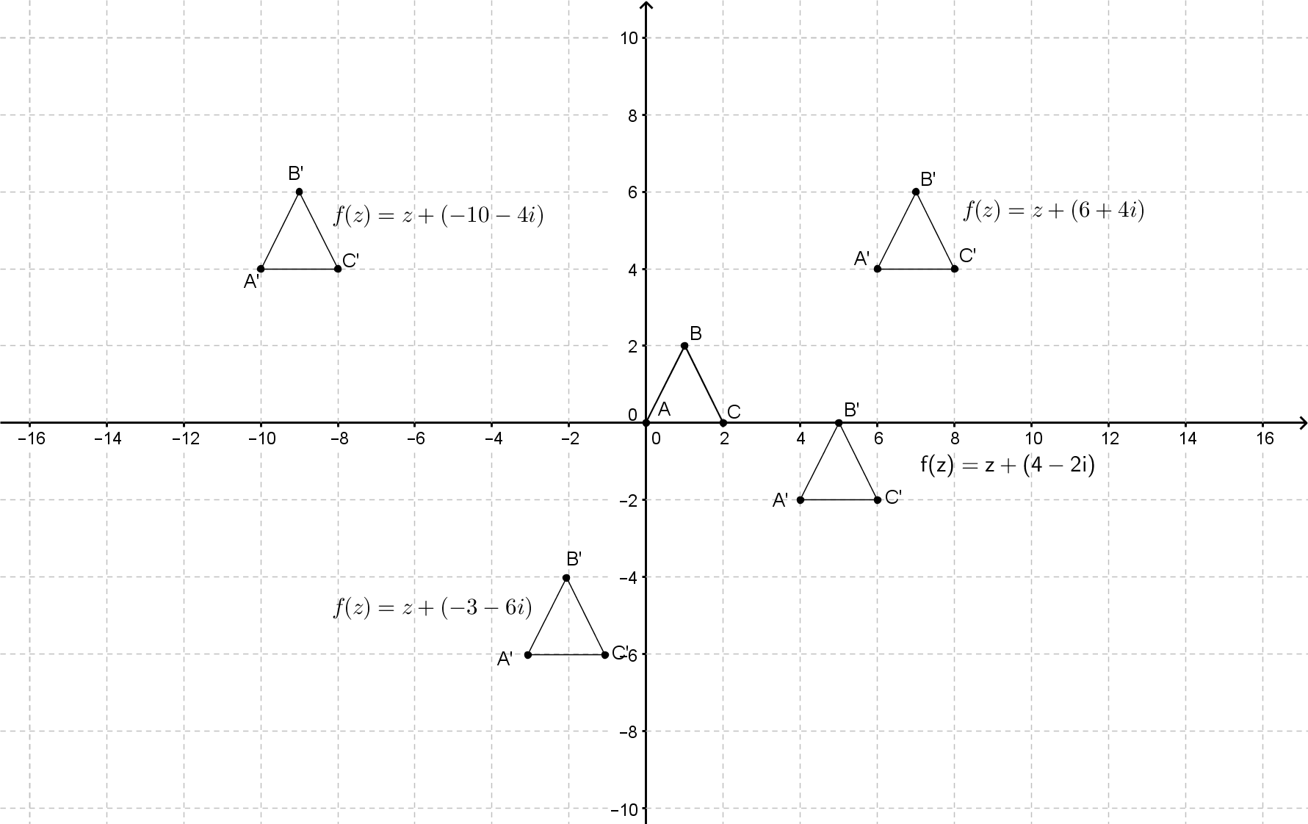

Marking key/mathematical behaviours | Marks
- Correctly plots at least three images | 3

Question 1 (d)

The transformation represents a translation with translation vector .

Marking key/mathematical behaviours | Marks
- Identifies the transformation is a translation  - Gives a description of the translation | 1  1

Question 2 (a)

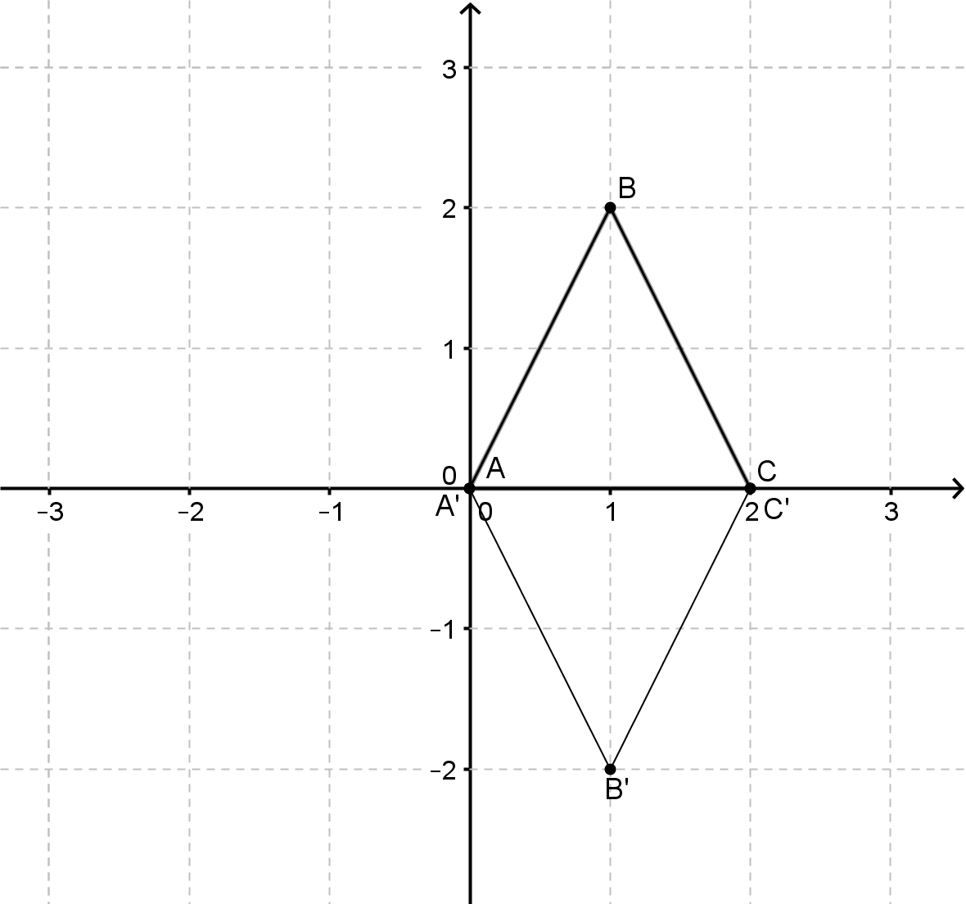
Marking key/mathematical behaviours | Marks
- Correctly determines the image of the three vertices  - Plots the three images | 1  1

Question 2 (b)

The transformation represents a reflection in the horizontal axis.
Marking key/mathematical behaviours | Marks
- Correctly identifies the transformation | 1

Question 2 (c)

The transformation represents a reflection in the vertical axis
Marking key/mathematical behaviours | Marks
- Correctly defines the transformation | 1

Question 2 (d)

The transformation represents a reflection in the line .
Marking key/mathematical behaviours | Marks
- Correctly defines the transformation to be of the form  - Determines | 1  1

Question 2 (e)

The transformation represents a reflection in the line .
Marking key/mathematical behaviours | Marks
- Recognises the coordinates of a point are interchanged  - Correctly defines the transformation | 1  1

Question 3(a)

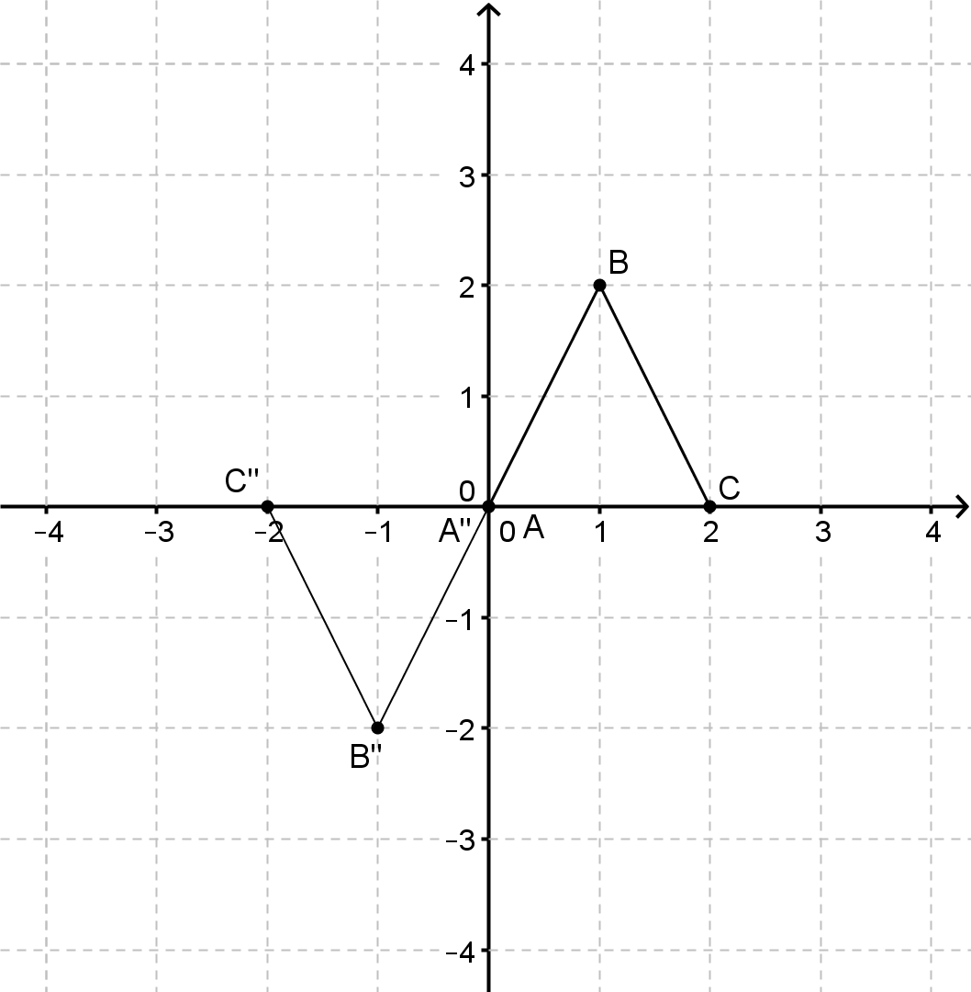
Marking key/mathematical behaviours | Marks
- Correctly determines the image of the three vertices  - Plots the three images | 1  1

Question 3 (b)

The transformation represents a rotation of about (0,0).

Marking key/mathematical behaviours | Marks
- Correctly identifies the transformation | 1

Question 4(a)

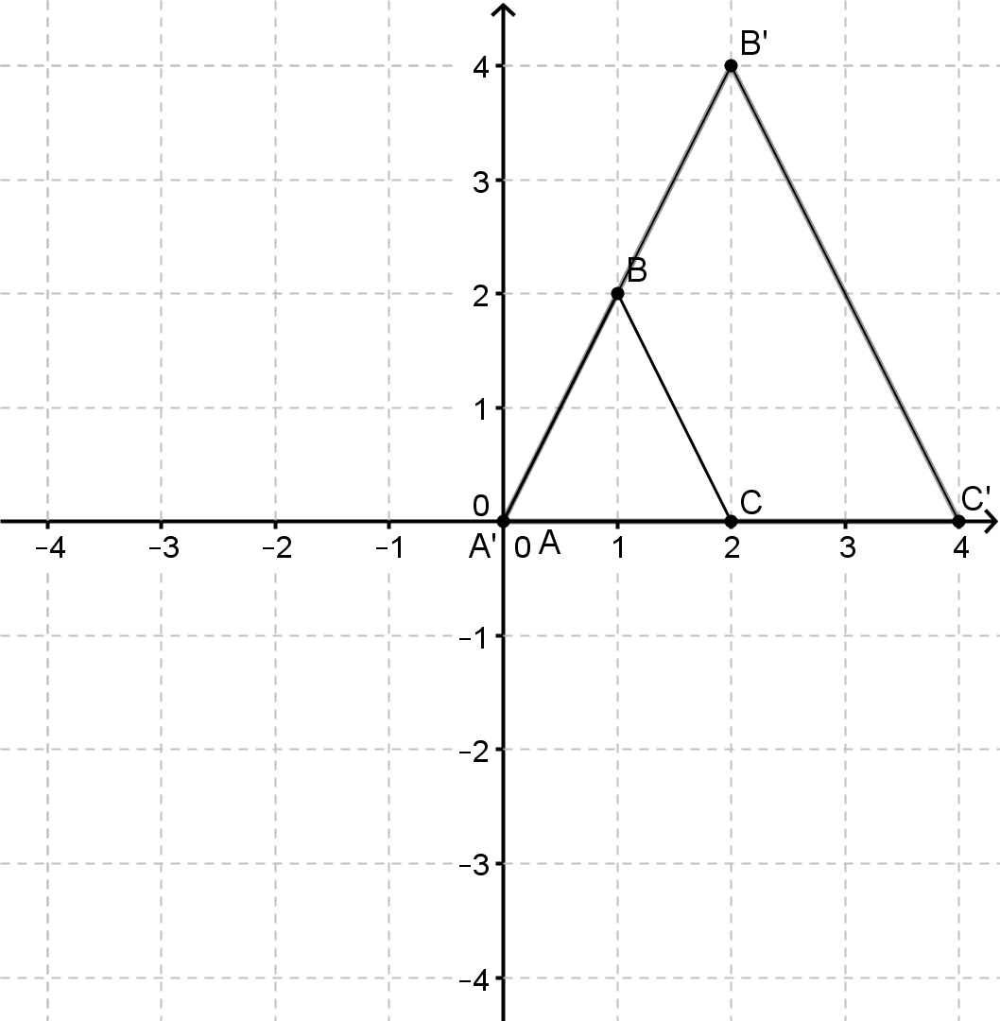
Marking key/mathematical behaviours | Marks
- Correctly determines the image of the three vertices  - Plots the three images | 1  1

Question 4(b)

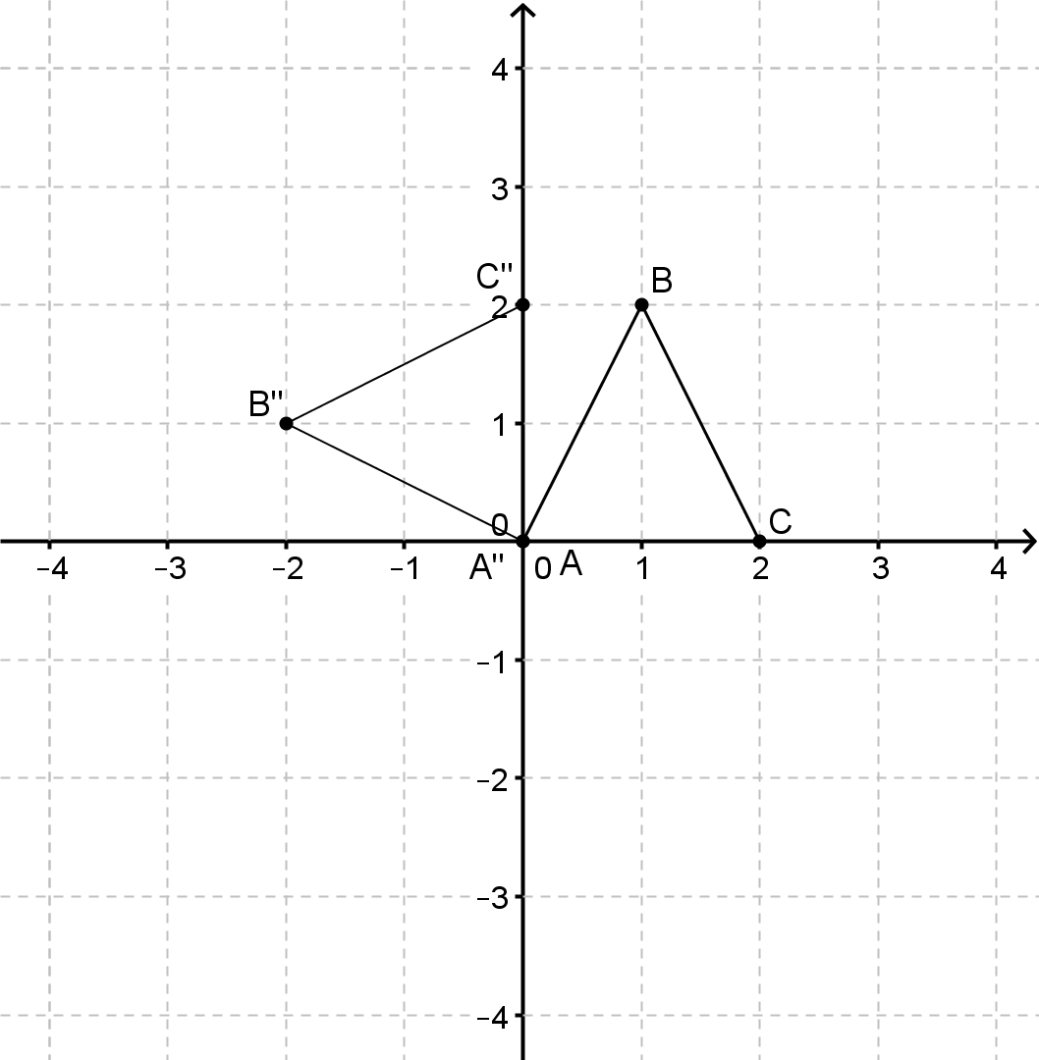
Marking key/mathematical behaviours | Marks
- Correctly determines the image of the three vertices  - Plots the three images | 1  1

Question 4(c)

The transformation represents a dilation scale factor k centre (0,0).

Marking key/mathematical behaviours | Marks
- Correctly defines the transformation | 1

Question 4(d)

The transformation represents an anti-clockwise rotation of about (0,0).

Marking key/mathematical behaviours | Marks
- Correctly defines the transformation | 1

Question 4(e)

Using
Using
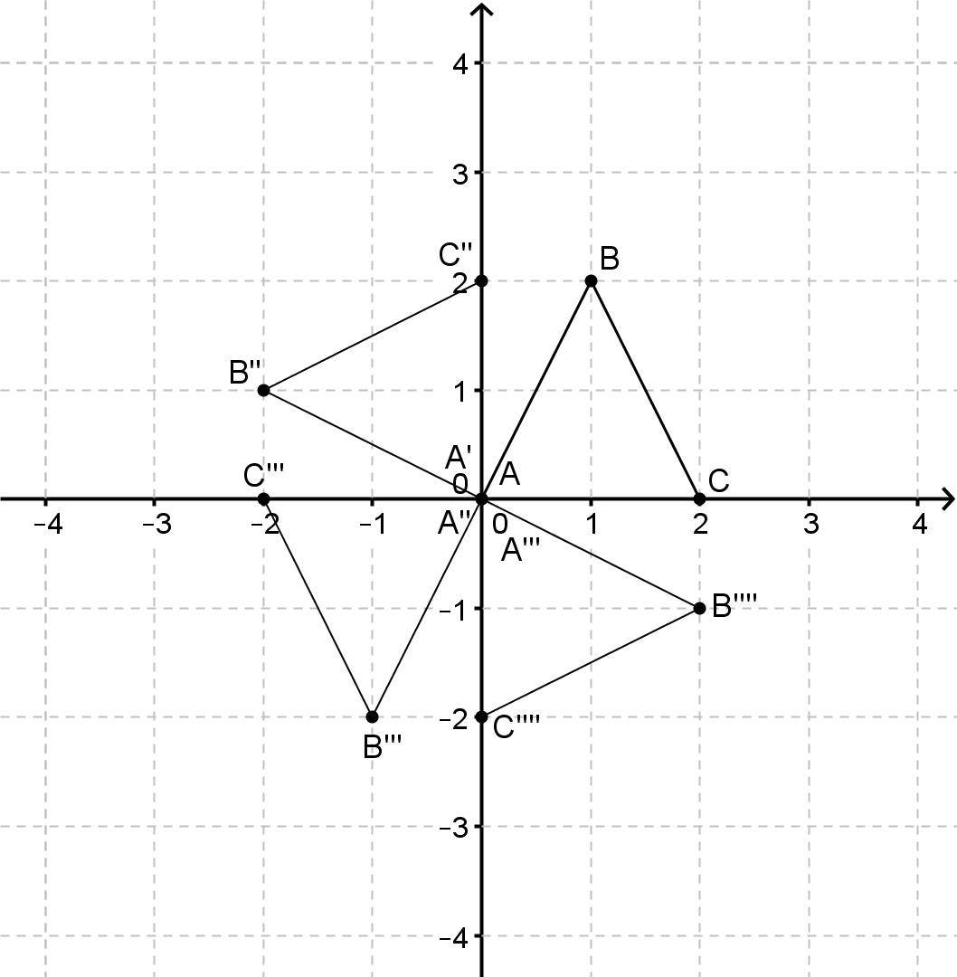
Since,
The transformation represents anti-clockwise rotations of about (0,0).

Marking key/mathematical behaviours | Marks
- Correctly determines the images for  - Correctly determines the images for  - Establishes the pattern for  - Correctly defines the transformations | 1  1  1  1

Question 5(a)

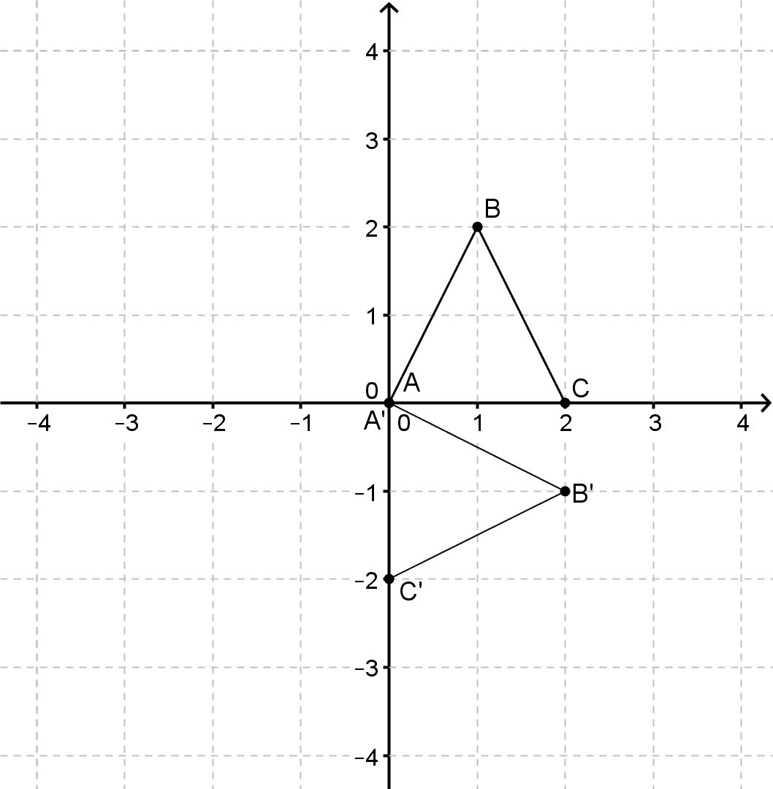
Marking key/mathematical behaviours | Marks
- Correctly determines the image of the three vertices  - Plots the three images | 1  1

Question 5(b)

Either:
- the transformation represents a clockwise rotation of about (0,0)
or
- the transformation represents an anti-clockwise rotation of about (0,0)
Marking key/mathematical behaviours | Marks
- Correctly defines the transformation | 1

Question 5(c)

a rotation of about (0,0)
an anti-clockwise rotation of about (0,0)
the object and the image are the same
a clockwise rotation of about (0,0) (or equivalent description)
In general, for

Marking key/mathematical behaviours | Marks
- Correctly determines the transformations for  - Correctly determines the images for and for  - Correctly determines the images for  - Establishes the pattern for | 1  1  1  1

Question 6(a)

A dilation scale factor 4 centre (0,0) followed by a translation with translation vector .

Marking key/mathematical behaviours | Marks
- Correctly identifies the dilation and scale factor  - Correctly identifies the translation vector  - Gives transformations in the correct order | 1  1  1

Question 6(b)

A reflection in the horizontal axis and a translation with translation vector .
Marking key/mathematical behaviours | Marks
- Correctly identifies the reflection  - Correctly identifies the translation vector | 1  1

